Sprint 4 Report:

Shared Spoons, Team Foodies, 2 Dec 2024

• Actions to stop doing:

* Nothing, Everything has been ironed out. We are satisfied because our work is being completed on time with no miscommunication. We are also at the point where everyone can work independently with no need to directly communicate for every instance of work.

• Actions to start doing:

* No next sprint, the team has reached a point where there is no longer anything to change.

• Actions to keep doing:

* Everything listed through the reviews as what to keep doing has carried through and none of them have been discarded.

• Work completed/not completed:

* Completed
* As a user I would like to be able have a welcome page to set my initial preferences
* Not Completed
* As a user I would like to be able to receive notifications from the app
* As a user, I would like to see a dish of the day at the top of my home page
* As a user, I would like to be able to access a recommended foods, “new eats”, within the explore page

• Work completion rate:

* Stories completed: 1 User Story
* Hours completed: 30 per person.
* Days worked: 10 out of 14 estimated per person
* Nov 20 (3.5 Hours / Person): As a user I would like to be able have a welcome page to set my initial preferences
* Nov 21 (3.5 Hours / Person): As a user I would like to be able have a welcome page to set my initial preferences
* Nov 22 (3.5 Hours / Person): As a user I would like to be able have a welcome page to set my initial preferences
* Nov 25 (3.5 Hours / Person): As a user I would like to be able have a welcome page to set my initial preferences
* Nov 26 (3.5 Hours / Person): Not a user story, app clean up and error corrections.
* Nov 27 (2.5 Hours / Person): Not a user story, app clean up and error corrections.
* Nov 28 (2.5 Hours / Person): Not a user story, app clean up and error corrections.
* Nov 29 (2.5 Hours / Person): Not a user story, app clean up and error corrections.
* Dec 1 (2.5 Hours / Person): Not a user story, app clean up and error corrections.
* Dec 2 (2.5 Hours / Person): Not a user story, app clean up and error corrections.

Burn Up Chart:

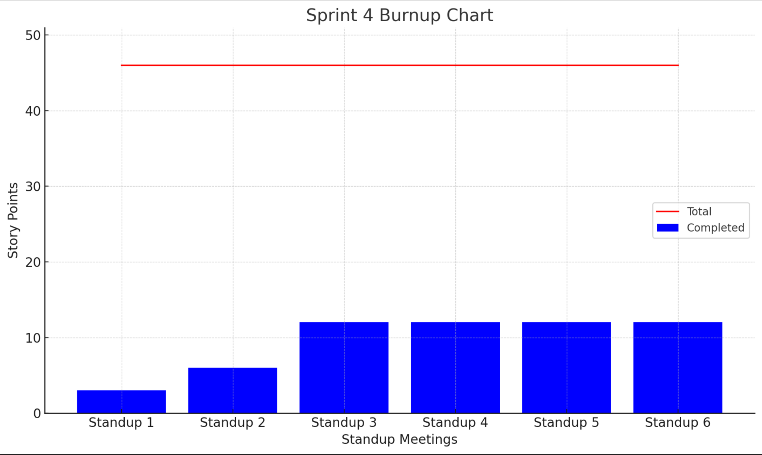

The sprint 4 consisted of mainly fixing everything needed to smooth out the app and to backlog the new features. This is due to the issues stated in the meetings.